Biography: 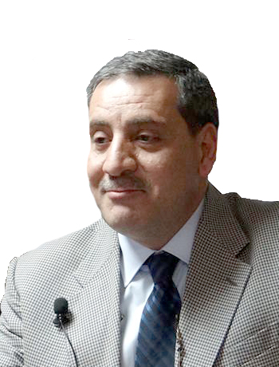

Dr. Emad Salloum

Dr. Salloum Graduated from Dental School Damascus University on 1981, where he completed his residency program in Oral& Maxillofacial Surgery on 1986, he also attended an extern fellowship training at Emory Univ. And Emory clinic 1989, 1992, 1998. He is also a Diplomate of ICOI, a board member of Syrian Association of Oral& Maxillofacial Surgery, and editorial board member an of Syrian Association of Implant Dentistry, Dr.salloum is an international Ambassador for ICOI, and Ambassador of Digital Dentistry Society, AmericanAcademy of Oral Surgery, International Academy of Ultrasonic Surgery .He is a speakers for the British Academy of Implant and Restorative Dentistry (BAIRD), and international expert on Dental XP.
Dr. Salloum had been lecturing in several regional and international conferences , and published several clinical studies . He is a chief surgeon and director of Salloum Dental Clinic and training center.

